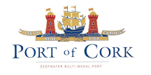
Procedure SEMS 06.08
First issue: 14.10.04
Revision: 1 date: 07.12.05

PORT OF CORK

NOTICE TO MARINERS

NO. 12 OF 2018

PILOT TRANSFER ARRANGEMENTS AND SAFE MEANS OF ACCESS

Masters, Owners, Operators and Agents of all Vessels calling to the Port of Cork are hereby notified of the requirement to provide a safe working environment for Pilots while they are on board and during embarkation and disembarkation.
The Master of any vessel subject to compulsory pilotage or which requests the service of a Pilot must ensure that their vessels comply with a safe means of access for pilots boarding or landing and that the pilot transfer arrangements are rigged and manned in accordance with SOLAS Chapter V, Regulation 23 and IMO Resolution A.1045 (27).
Pilots may not board a vessel which has rigged a non-conforming or defective pilot transfer arrangement. Any pilot not boarding a vessel for such reasons will have the full support and backing from the Port Company. Defects will be reported immediately to Port State Control.
Vessels which have been refused pilotage will subsequently be asked to anchor in the nearest safe anchorage or refused clearance to sail until the matter/defect is rectified.
Further guidance information is available from the IMO and International Marine Pilots Association;
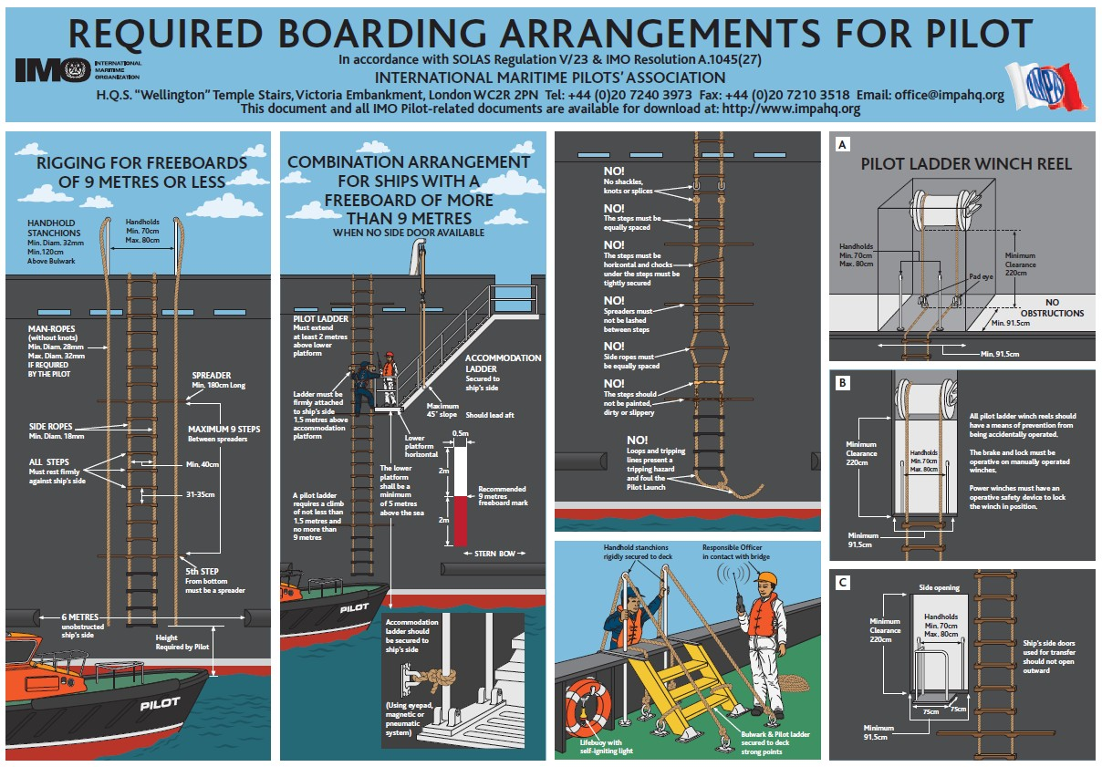

www.ics-shipping.org/docs/default-source/resources/safety-security-and-operations/shipping-industry-guidance-on- pilot-transfer-arrangements.pdf

CAPTAIN P. O’REGAN

HARBOUR MASTER

CUSTOM HOUSE STREET,
CORK.

20/09/2018

