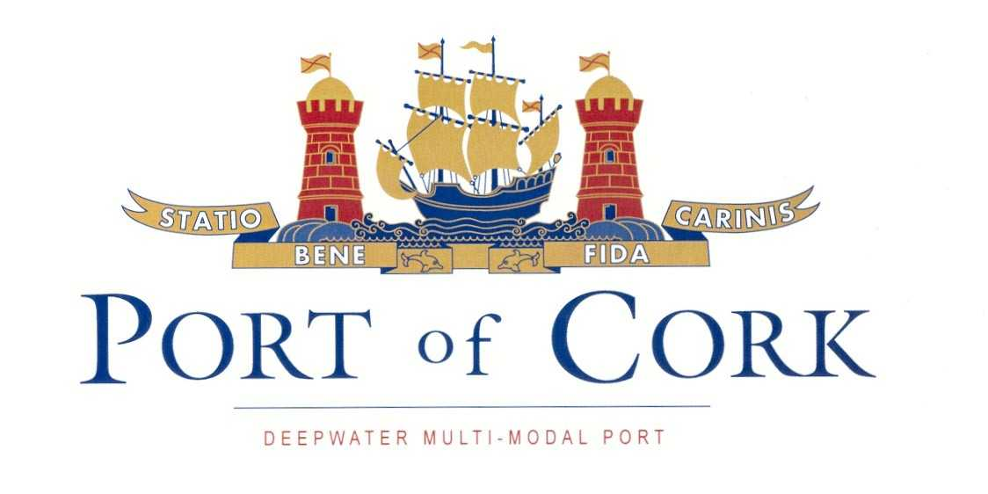
Procedure SEMS 06.08
First issue: 14.10.04
Revision: 1 date:07.12.05

NOTICE TO MARINERS

ESB Submerged power cables

NO. 4 of 2014

Admiralty Chart No 1773/1777

Mariners are advised of two locations where the ESB has installed submerged 220kV power cables. Charts, showing cable runs, are available on the Port of Cork website in the “Notice to Mariners” section. Each run consists of four individual cables, the overall width of each cable run is approx. 100 metres.

- Aghada to Cuskinny
From 51 50.3’N 008 13.8’W (Aghada) to 51 50.52’N 008 15.9’W (Cuskinny.)

- Corkbeg to Ringaskiddy
From 51 49.44’N 008 15.0’W (Corkbeg) to a turning point on the west side of the navigation channel 51 49.1’N 008 16.6’W to
51 49.85’N 008 18.10’W (Ringaskiddy).

Mariners should avoid anchoring on or near the cable locations.

CAPTAIN P. O’REGAN,

HARBOUR MASTER

CUSTOM HOUSE STREET,
CORK.
13TH JANUARY 2014.

