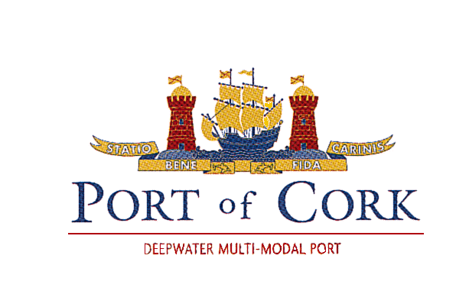

**PORT OF CORK COMPANY**

**TOWAGE REQUIREMENTS & INFORMATION**

**5th November 2019**

**Introduction**

This booklet has been produced to provide a source of information on tugs and towage procedures for Masters of vessels using the Port of Cork. Requirements on minimum standards for Crew, Training, Vessels and Operations are set out within this document.

It should be read, as appropriate, in conjunction with the Ports Minimum Towage Matrix and Port of Cork Byelaws (Navigation and Towage). The Minimum Towage Matrix (separate document) outlines in detail by berth /area the towage requirements for most vessels that call at the Port. The matrix forms part of the Port of Cork’s Safety Management Systems and is updated as required. Minimum Towage Matrix guides are effective for average wind speeds up to 20Kts. For wind speed in excess of 20Kts, Towage requirements will be assessed by the Pilot and Master and confirmed with the Harbour Master or Deputy HM.

The allocation of tugs is subject to order by the shipping agent to the **Senior Berthing Master** under normal circumstances and based on the minimum towage matrix guidelines. **The Harbour Master or the Deputy Harbour Master may at any time allocate specific tugs to any vessel that requires special attention based on vessel design, weather conditions/ tidal conditions expected or prevailing within the harbour.**

**Captain Paul O’Regan**

**Harbour Master**

**Port of Cork Company**

**Index**

|  |  |  |
| --- | --- | --- |
| 1. | Minimum Towage Requirements | P.3 |
| 2. | Professional Qualifications and Training Requirements | P.3 |
| 3. | Vessel requirements | P.4 |
| 4. | Environmental Compliance | P.4 |
| 5. | Safe Manning | P.5 |
| 6. | Licence Approval Process | P.6 |
| 7. | Safety Management System | P.8 |
| 8. | Vessel Maintenance | P.9 |
| 9. | Temporary Approvals for Non-Licenced Operators | P.10 |
| 10. | Pilot Exemption Holders | P.10 |
| 11. | Procedure to obtain towage services | P.10 |
| 12. | Preparing for Towage Operations | P.11 |
| 13. | Safe Speed | P.11 |
| 14. | Towage in restricted Visibility | P.11 |
| 15. | Whitegate Refinery | P.12 |
| 16. | Escort Towage | P.12 |
| 17. | Communications | P.12 |
| 18. | Pilot/Tug Master Information and Training | P.12 |
| 19. | Tug Defects | P.12 |
| 20. | Notes – Special Requirements | P.13 |
| 21. | Approved Tugs based at Port of Cork | P.13 |
| 22. | Review Procedure | P.19 |
| 23. | Complaints Procedure | P.19 |
| 24. | Blank |  |

1. **Minimum Towage Requirements**

Port of Cork Company has published the minimum Towage requirements which is available for download on our website [www.portofcork.ie](http://www.portofcork.ie) , under the Port Operations tab.

These requirements state the minimum towage for each berth/area, based on specific vessel dimensions and characteristics. It should be noted that these are minimum requirements and in no way prevent the Master of a vessel, or the Port Authorities from increasing the number or size of tugs as they see necessary. Where requirements state “individually risk assessed”, the Harbour Master in consultation with the ship’s Pilot and Master as appropriate, will decide upon the necessary towage required.

1. **Professional Qualifications and Training Standards**

The vessel shall be manned by skilled and competent crew as follows: -

2.1 The Master shall possess as a minimum a Certificate of Competency as Master (Near Coastal Area) or Valid STCW A-II/3. Alternative qualifications may be accepted based on Towage experience and satisfactory knowledge of the harbour upon examination by the Harbour Master.

2.2 All crew must hold the applicable STCW qualifications as are necessary for the safe operation of the vessel. As a minimum requirement, all crew should complete basic safety training in:

Personal Survival Techniques (PST) – STCW approved

Basic First Aid and Fire Safety

All crew shall be medically fit to undertake onboard functions

**Further as part of the SMS:**

1. The Owner shall establish procedures to ensure that new personnel and personnel transferred to new assignments related to on board operations are given proper familiarisation with their duties;
2. ensure that personnel involved in the Owner’s SMS have an adequate understanding of relevant rules, regulations, codes and guidelines, and apply them as required;
3. establish and maintain procedures for identifying any training, which may be required in support of the SMS and ensure that such training is provided (including refresher training as necessary) for all personnel concerned;
4. establish procedures by which the vessel’s personnel receive relevant information on the SMS in English; and ensure that the vessel’s personnel are able to communicate effectively in the execution of their duties related to the SMS and vessel operations.
5. All persons engaged by the Towage Company must have ISPS (International Ship and Port Security Code) clearance and identification cards issued by the Port Facility Security Officer.
6. Documentary proof as to qualifications, experience and training of key personnel shall be made available on request to the Harbour Master or such person as shall be authorised by him.
7. **Vessel Requirements**

The Port of Cork Company requires all Towage Service Providers operating in the Port to comply with the following minimum standards as per existing byelaws

1. The vessels shall be classed with a Classification Society, or a competent authority, approved by the Harbour Authority, as tug class + 100A1 hull and Lloyds Machinery Certificate (LMC) machinery or equivalent and shall be maintained in class at all times.

(2) The vessel shall be equipped with VHF radio channels 16, 6, 8, 11, **12**, 13, 14.

(3) The vessel shall hold a Safety Equipment Record of Inspection, a Radio Station Licence and a set of up-to-date editions of Admiralty Charts (duly corrected) or an approved EDCIS for the Port area.

(4) Towing equipment shall be suitable for the job in hand and shall be maintained to a high standard and inspected on a regular basis. An emergency quick release system shall be provided and be capable of being activated independently from the bridge and/or the deck.

(5) Bollard pull shall be measured and certified at intervals or not more than five years and the measurement witnessed by an independent surveyor.

1. **Compliance with Environmental Requirements**

4.1 Towage Service Providers shall comply with all applicable local, national and international environmental legislation.

All vessels must comply with relevant international, national and local requirements, for the prevention of marine pollution applicable to the vessel and the area in which it is operating. Responsibility for the vessel to be properly equipped and maintained and to ensure that the Master receives up-to-date and adequate information rests with the Owner.

4.2. Oily residues and garbage or refuse and other wastes must be landed ashore at proper disposal facilities and not discharged or disposed of overboard. All vessels operating under this license must display placards informing the crew of the disposal requirements of garbage under MARPOL.

1. **Safe Manning**

**5.1**. The numbers of certificated and non-certificated crew must always be sufficient to ensure safe and efficient operation of the vessel as determined by a comprehensive risk assessment undertaken by the Owner, the requirements of the National Licencing Authority (MSO)/Flag and agreed by the Harbour Master.

In fulfilling their responsibility to ensure that vessels are safely and sufficiently manned, Owners shall:

1. make an assessment of the tasks, duties and responsibilities of the vessel’s complement, required for its safe operation, for the protection of the marine environment and dealing with emergency situations; then
2. assess the numbers and grades/capacities in the vessel’s complement required for the safe operation, for the protection of the environment, and for dealing with emergency situations; and always
3. ensure that the identified manning and competency levels are adequate at all times and in all respects, including meeting peak workloads and in accordance with the principles contained in this Section; (d – i)
4. in case of changes in trading area(s), operations, construction, machinery, equipment or operation and maintenance of the vessel, which may affect the safe manning, the Owner must review the level of manning and revise the competency requirements as necessary;
5. identify all the functions to be undertaken on board during a representative passage or operational period, including determination of the number of personnel required to undertake the relevant tasks and duties under both peak and routine work load conditions;
6. identify those functions that constitute a normal operation and determine the numbers of personnel required to undertake the concurrent tasks and duties safely;
7. identify the skills and experience required to perform those functions;
8. establish working arrangements to ensure that the master and crew are capable of undertaking concurrent and continuing operations at the appropriate level(s) of responsibility, as specified, with respect to their skills and training; and
9. ensure that the working arrangements allow for sufficient rest periods to avoid fatigue and to comply with the appropriate requirements on Working Time Regulations.

**5.2** . The Owner will consult with the Port of Cork on their proposed manning levels. Once agreed, a record of the consultation process should be retained by the Owner, together with a record of the agreed manning level.

**5.3.** Changes should not be made to the manning level unless they can be justified by substantially altered work patterns made necessary, for example, by a change in operation or other significant factor. Where a vessel is known to engage in an irregular operational pattern or have working hours that are unlikely to be uniform, this should be taken into account when considering the manning level.

**5.4**. Once agreed, the Owner should ensure the safe manning level is maintained.

1. **Licence Approval Process**





**Assessment Criteria:**

6.1 When evaluating a tug or workboat and its crews’ suitability to operate on their vessel, the following issues, focussed on Ship Assist Towage, will be assessed:

1. Master and crew experience and in-house training;
2. Master and crew certification and manning policy;
3. Master’s knowledge of tug stability, girting and vessel interaction;
4. Master’s knowledge of company SMS and compliance requirements
5. Master’s awareness of watertight integrity issues when towing;
6. Capability of the tug;
7. Crew’s general safety culture, tool box talks, pre-operational briefings;
8. PPE standards and knowledge of required use;
9. Charts relevant and in date;
10. Communication equipment checks;
11. Condition and maintenance standards of the tug/workboat;
12. Towing winch emergency release mechanisms proven (frequency of checks).

6.2 Local Knowledge Assessment

When evaluating a tug or workboat and its crews’ suitability to operate their tug/workboat within port limits the following issues, focussed on Port Familiarisation, will be assessed:

1. Master’s knowledge of relevant directions, bye laws, contingency plans and guidelines;
2. VTS areas and procedures, communications and VHF channels;
3. Master’s knowledge of generic or own passage plans;
4. Channel widths, courses and distances, swinging circle and basin distances;
5. Navigation marks/aids, berths wharfs, quay names;
6. Depth of water at berths and channels in all areas;
7. Anchoring, pipelines and cables;
8. Leisure craft activity;
9. Reporting incidents and accidents to Harbour Master
10. Speed limits within the harbour and due regard to other harbour users.

6.3 Emergency Response

The crews’ must confirm their knowledge and familiarisation with:

1. Training and Exercises with regard to man over-board,
2. Response to an oil spill incident,
3. Response to girting – risk assessments and control measures;
4. Environmental issues such as garbage control measures.
5. **SMS (Safety Management System)**

Vessels subject to this Code of Practice shall maintain an operational Safety Management System (SMS). The overall objectives of the SMS are to ensure safety, prevention of injury or loss of life, and avoidance of damage to the vessel, the environment, in particular to the marine environment, and to property.

7.1 Specifically the safety management objectives of the Owner should as a minimum:

1. provide for safe practices for the vessel’s navigation and operation, and a safe working environment for the crew;
2. establish safeguards against all foreseeable risks; and
3. continuously improve the safety-management skills of personnel ashore and aboard the vessel, including preparing for emergencies related both to safety and environmental protection.

7.2 The SMS should ensure:

1. compliance with all mandatory rules and regulations; and
2. that applicable codes, guidelines and standards recommended by the Port Company and where appropriate, the Marine Survey Office, and/or Certifying Authorities, Classification Societies, are taken into account.

7.3 Operational Policies

The Owner should establish policies, which describe how the functional requirements identified in this Code of Practice, as applicable, will be achieved.

The Owner should ensure that the policies are implemented and maintained in all aspects of the vessel’s operation.

7.4 Functional requirements for the SMS

7.4.1 Owners are to establish and maintain a structured, operational SMS. They should utilise and develop a SMS, which reflects their specific vessel operations.

7.4.2 As a minimum the SMS should include, but not necessarily be limited to, the following functional requirements:

1. Lines of communication and defined levels of authority between and amongst, shore management and vessel crew;
2. Master and crew responsibilities;
3. Health & Safety requirements;
4. Personnel competency and training;
5. On-board procedures including vessel and equipment maintenance;
6. Procedures for the reporting or accidents and navigational incidents;
7. Procedures to respond to emergency situations;
8. Procedures to protect the marine environment;
9. Mooring operations;
10. Navigation and Passage Planning;
11. Demonstrating compliance with all applicable IMO, national/Flag, local and port regulations;
12. procedures to prepare for and respond to emergency situations;
13. procedures for non-conformances, internal audits and management reviews.

Compliance with the requirements of the SMS will be checked by the Port Company at each inspection by auditing documentation on the vessel and ashore.

1. **Vessel Maintenance**

8.1 The Owner should establish and maintain procedures to ensure that the vessel and its equipment (including towing equipment, as appropriate) are maintained to a safe operating condition at all times.

8.2 Procedures shall ensure:

1. inspections and audits are held at appropriate intervals;
2. any non-conformity is reported internally, with its possible cause, if known;
3. appropriate corrective action is taken; and
4. records of these activities are maintained and available for inspection by HA.
5. Towline records (no. of tows, no. of towage hours, end for end dates)

8.3 The Owner should establish and maintain procedures in its SMS to identify equipment and technical systems, to which the sudden operational failure may result in hazardous situations. The SMS should provide specific measures aimed at promoting the reliability of such equipment or systems. These measures should include the regular testing of stand-by arrangements and equipment or technical systems that are not in continuous use. A routine planned maintenance system shall be established and in use on each vessel.

**8.4 Annual Inspections.**

8.4.1. The Port Company will carry out an annual inspection of the owner’s vessel to confirm condition criteria is maintained. The Towage Company shall notify and arrange suitable inspection dates with the Port Company at least four weeks in advance of anniversary dates.

8.4.2. The results of the inspection, and any restrictions on the vessel’s use, will be recorded and discussed with the vessel’s owner and operator.

1. **Temporary Approvals for visiting Tugs**

The Harbour Master may grant a temporary approval for towage within the jurisdiction of the Port of Cork Company to a Towage Company/Individual that has been engaged to undertake a “tow” to/from the Port or operate on a specific project (non-routine) within the Port jurisdiction for a period of time.

Approval are considered upon request; towage companies/individuals must submit the required documents related to Part 3, 4 & 5 of this document prior to arrival and/or commencement of duties within the Port.

Such vessels may be subject to Pilotage for the full or part duration of the port stay. Temporary approval are valid for a period of 14 days: extensions beyond this time may be requested by the towage company/individual in writing to the Harbour Masters office.

1. **Pilot Exemption Holders (PEC)**

The minimum towage requirements apply to all PEC holders, however a Pilot must at all times be engaged if a vessel with a PEC holder in command has engaged the services of a Tug within the Port limits.

1. **Procedure for Obtaining Towage Services**

Towage services can only be provided by Port of Cork Company approved and licenced Towage providers.

Towage requests within the Port of Cork are arranged via the appointed **Ships’ Agent** to the Senior Berthing Master for POCC who will then liaise with Pilots and Towage providers, or the vessels Master via his Agent or through Port Operations in \**exceptional circumstances.*

All towage providers within the Port can provide tug assistance at two hours’ notice, therefore the Master may order any tugs that he/she may require through his/her Agent taking this notice period into consideration. Emergency towage may be available at shorter notice as per the towage providers schedules.

When ordering Tugs, the Agent must specify to the Senior Berthing Master which company and tug they wish to be appointed on behalf of the ship-owner.

*In cases of emergency, that is when the Master or Pilot of a vessel deem that towage is required to safely execute a transit, manoeuvre or to assist a berthed vessel to remain alongside, the Port Operator is authorised to allocate any towage resources immediately available to go the assistance of the vessel.

Nothing in these procedures prevent the Harbour Master from allocating towage to any vessel he considers necessary.

Except in cases of emergency or otherwise as directed by the Harbour Master or the Deputy HM, an inbound vessel requiring the services of a tug, will not be permitted to pass Roches Point until the Tug has confirmed it is ready to be mobilised.

1. **Preparing for all towage operations**
2. Planning and Co-ordination

Before beginning towing operations, a comprehensive plan, (as part of the ship’s port passage plan and the pilot’s own plan), should be discussed and agreed by both the Master and Pilot, where a Pilot is embarked. This should take account of all relevant factors, including:-

* tide,
* wind,
* visibility,
* ship size,
* type and characteristics of the towed vessel
* specific berth requirements.

A good knowledge of the type and capabilities of the tugs allocated to the job is important, in order that the Master / Pilot can ensure tugs are both suitable for the task ahead and positioned on the vessel so as to be most effective to facilitate a safe operation. Any conflict or mismatch between the required manoeuvre and the tugs allocated must be resolved prior to the start of the towage operation. Responsibility for co-ordinating a towage operation lies with the Master in consultation with the Pilot.

1. **Safe speed**

This is a critical factor for the tug when making fast and letting go. When considering speed, it is the speed through the water that is of concern. It is generally accepted that 5 to 6 knots is appropriate when making fast and letting go tugs within the harbour, however this may be altered with general agreement between the Tug Skipper and Pilot, due consideration should be given to tugs manoeuvring astern.

Tug Skippers shall at all times comply with Port byelaws and instructions relating to Safe Speed, attention is drawn to the Navigation Byelaws, part 3, Byelaw No. 8 “Speed of vessels”

1. **Towage in Restricted Visibility**

Towage during periods of restricted visibility has its own inherent risks and is normally not routine activity, however occasions do occur when towage operations have commenced, and the visibility deteriorates. The Pilot / Master and the Tug master will discuss the situation immediately and agree upon a course of action to ensure the safety of all personnel and vessels involved given the location, environmental and vessel traffic conditions, seeking the advice of Port Operations as appropriate. The Pilot or Master will advise Port Operations of the circumstances and any decisions made immediately, keeping all concerned informed of any operational developments, or any improvement or deterioration of the visibility. The Tug master should immediately inform the Pilot / Master of any concerns that he may have as to the safety of his tug and crew. The Pilot / Master and Tug master should take immediate action to ensure the safety of both the tug and the assisted vessel. If necessary, the operation may be aborted as soon as it is safe to do so.

1. **Whitegate Refinery:**

***For all inbound/outbound to Whitegate Marine Terminal***

The detailed tug for all single tow operations is the contracted refinery Tug, when available. Please refer to the Irving Oil Refinery “Marine Terminal Handbook”

1. **Escort Towage:**

For loaded crude tankers, the tug will proceed to the Pilot boarding area outside the Harbour and follow the instructions of the Pilot with regards to escort duties.

***All other vessels***

Escort tugs will meet the vessels a minimum of 1 nautical mile south of Roches Point, however this distance may be increased by order of the Pilot or Master.

When in Escort mode, the Tugs line will at all times be connected to the vessel from the commencement of the job until

1. The vessel is clear of Roches Point (outbound)
2. The vessel is securely berthed (tugs may slip lines to reposition for berthing)
3. **Communications:**

Bridge to Bridge communications between the vessel being assisted and the tugs should primarily be established on VHF Channel 12 (Port working Channel). Thereafter a working channel should be selected by the Pilot/Master of the vessel being assisted for subsequent tug and berthing communications.

1. **Pilot/Tug Master Information and Training:**

Tug Masters and Pilots must have a clear understanding of the necessary requirements of all towage operations, such as the position of Tugs on the towed vessel, Type of towage service required, any limitations of the tug or the towed vessels.

Tug Masters and Pilots will meet formally on an annual basis to discuss operational issues.

1. **Tug Defects:**

Tugs shall operate to their highest capacity, however, mechanical defects or any occasion when a tow line parts should be reported to the Harbour Master. Pilot/Masters that encounter any defects, difficulties or sub-standard operational capability while engaged in a tow operation should report such as soon as possible to Harbour Master or Port operations.

1. **Notes:**

* It is assumed that all the towed vessel’s manoeuvring equipment is operational and effective. Where equipment is defective or inadequate, additional towage may be required.
* The same towage requirements will apply for vessels shifting between berths if a “rope shift” is not an option. Lesser requirements may apply in the case of a “rope shift”, such requirements will be set by the Harbour Master.
* The Harbour Master retains the right to override these Towage Requirements at any time.
* Cruise vessels, Ferries and Specialised ships are assessed individually, and towage requirements will be made known prior to arrival or departure.
* The Master of a vessel retains the right to request extra towage in excess of these requirements.
* The requirements are subject to the weather conditions prevailing and forecast at the time.
* Repaired or replaced tow ropes must be suitably tested and certified prior to towage operations.
* Vessels/Barges/Craft under tow may not enter the Harbour (Not closer than 1 mile south of Roches Point) without prior arrangements being agreed by the Harbour Master

1. **Tugs currently based and approved to operate within the Port**

|  |  |  |  |  |
| --- | --- | --- | --- | --- |
| **Tug Name** | ***Gerry O’Sullivan*** | ***DGS***  ***Alex*** | ***DSG***  ***Titan*** | ***Denis Murphy*** |
| Type | Voith Schneider | ASD | ASD | Twin Screw |
| Operator | Port of Cork Company | Doyle Shipping Group | Doyle Shipping Group | Port of Cork Company |
| **Bollard Pull** | **45t** | **45t** | **75t** | **12T** |
|  |  |  |  |  |
| Class | LR *100A1 tug, FiFi, LMC 06/02, UMS, DIRP 06/02 | DNV, +1A1 tug, EO, FiFi | LR *100A1 tug, FiFi, LMC 06/02, UMS, DIRP 06/02 | LR *100 A1 Launch |
|  |  |  |  |  |
| LOA (m) | 29.5 | 30.8 | 30.8 | 18.8 |
| Beam (m) | 11.45 | 11.14 | 11.19 | 8.36 |
| Draft (m) | 5.2 | 4.78 | 5.55 | 2.32 |
|  |  |  |  |  |
| Main Engines | 2 x Wartsila | 2 x CAT | 2 x CAT | 2 x CAT |
| Output | 1530kW ea | 2002HP ea | 1999kw ea | 360kW each |
| Props | 2 x Cycloidal | 2 x FP azimuthing | 2 x CP azimuthing | Twin Screw FP |
| Bow Thr (if app) | - | - | 150kw |  |
|  |  |  |  |  |
| Towing winch fwd Brake force | n/a |  | 150t | n/a |
| Towing winch fwd line | n/a | Rope (Dyneema) | Rope (Dyneema) 180m total | n/a |
| Towing winch aft Brake force |  |  | 150t |  |
| Towing winch aft line | Rope (Dyneema) |  | Wire (51mm) 762m total | Wire |
|  |  |  |  |  |
| Built | 1996 | 1995 | 2010 | 2005 |
| Minimum Crew | 3 | 3 | 3 | 3 |
| IMO Number | 9071258 | 9112741 | 9547855 |  |

**ALEX – DSG**

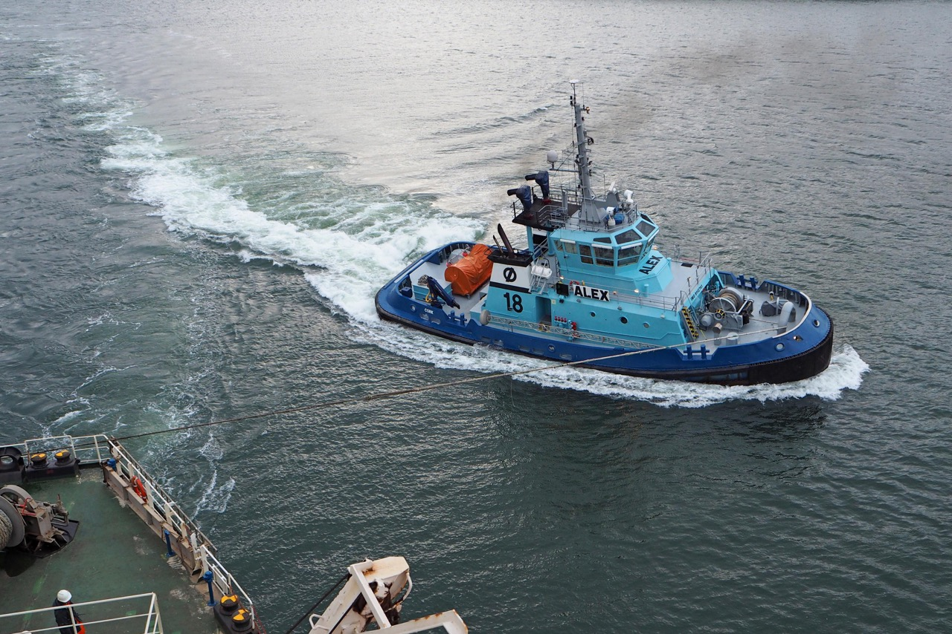

**DSG - Titan**

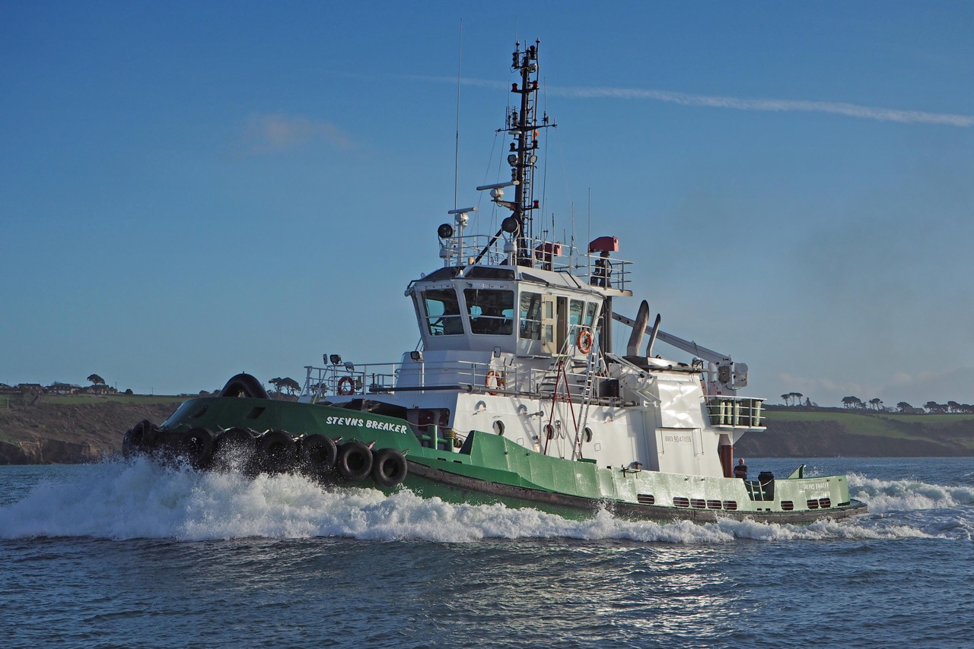

**Gerry O’Sullivan – Port of Cork**

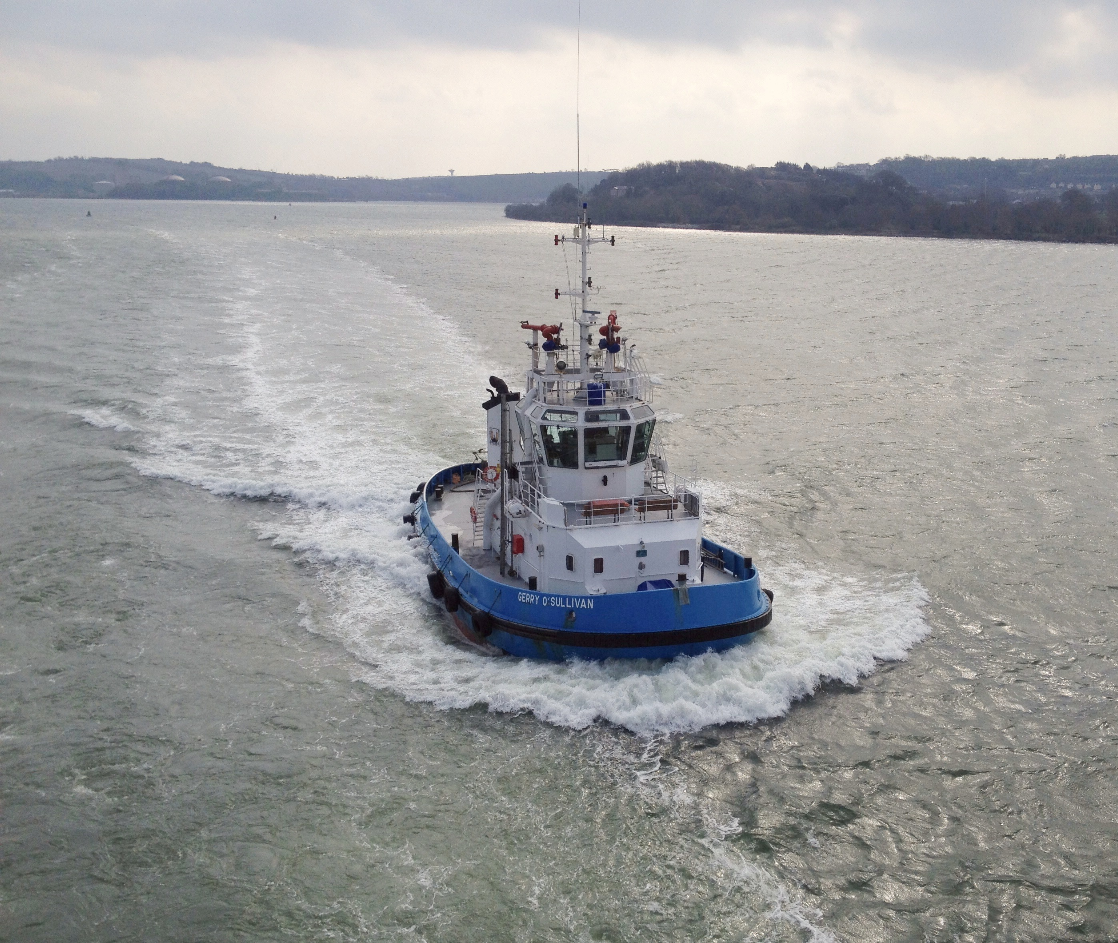

**Denis Murphy – Port Of Cork**

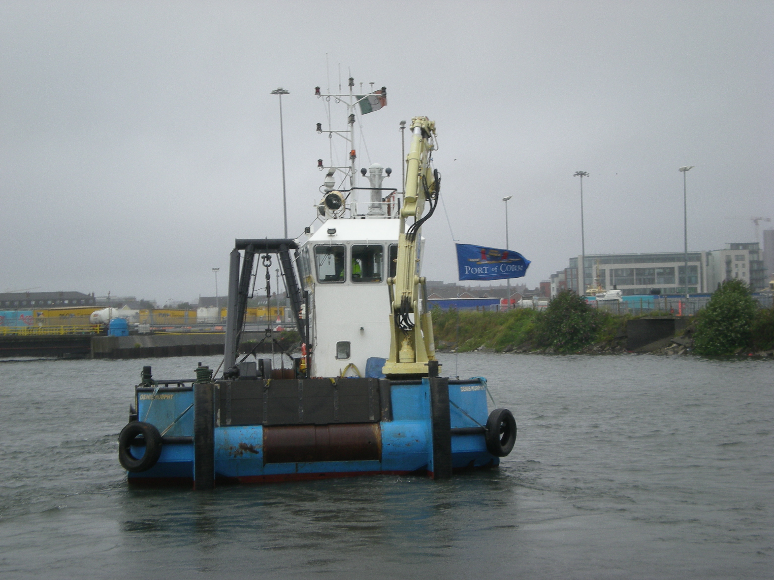

1. **Review Procedure**

These guidelines and matrix will be reviewed annually or upon occasion of a change in services or tugs provided by the service providers.

1. **Complaints Procedure**

Complaints relating to any towage operations shall be addressed to the Harbour Master on all occasions.