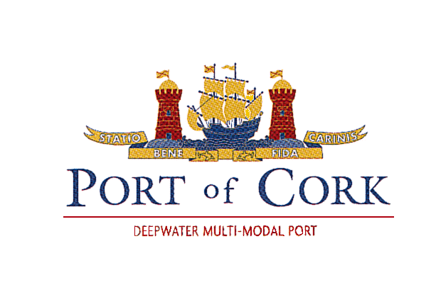

BOOKING POLICY CRUISE VESSELS POCC

Please note that the Port of Cork Company is changing our “first booked” policy for cruise vessel bookings, commencing 1st January 2019.
Due to the operational, logistical and safety requirements necessary to cater for large vessels with 2500 or more passengers onboard, Cobh Cruise Berth will be allocated to such vessels as a priority.

- MAXIMIUM NUMBER OF BOOKINGS ON A SINGLE DAY, NORMALLY 4 VESSELS.

- Cobh x1 – LOA 360m
- Ring x1 - LOA 350m
- Cork x1 - LOA 145m Draft ≤7.5m
- Anchorage x 1 - LOA 200m Draft ≤8.5m (Tendering)

The Port may accept a 5th booking for a city centre berth, the vessel size applicable
- LOA 130m Draft ≤6.5m
Vessel 4. above (anchorage) must apply for permission to tender when the Port Company confirm the booking. The tender permission is granted from the Department of Transport and must be sought via the cruise companys’ appointed agent.

- When two vessels with passengers numbers in excess of 2500 are booked for the same day….the rule of “first booked” will override point 2. above.

- The primary location offered for passenger turnarounds is Ringaskiddy. The terminal building has permanent and modern facilities for check-in and baggage screening. Vessels will berth nearby in Ringaskiddy or the Ferry terminal if feasible. Other Port areas’ may be utilised for turnarounds but will be considered on a case by case basis. Applicable turn-around charges will apply.

- Cancellation Charges: should a vessel cancel a confirmed scheduled call after January 1st of the arrival year. The cancelation charge shall be 30% of the full port charges. Unless for reason of force majeure.

- “While best efforts will always be made to accommodate vessels at their preferred berth, the Port of Cork reserves the right to allocate another berth to any vessel for operational or safety reasons.”

Harbour Master
Port of Cork Company

