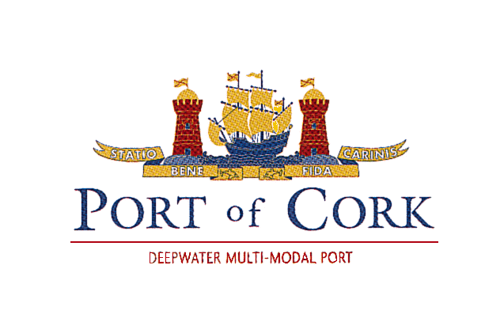

COMPLAINTS PROCEDURE

The following complaints procedure is applicable to Port Service Providers as set out in Regulation (EU) 2017/352
- INFORMAL PROCEDURE:

An informal approach can resolve most issues. Please contact the Company or approach one of our employees to discuss any complaint and seek resolution. All contact details are available on our website at the “Contact Us” page or call the Port Company office directly.

- Phone: +353 21 4273125 (in normal working hours Monday to Friday 9 am to 1 pm and 2 pm to 5pm) or
- Port Operations (24 hours) +353 21 4811380.

All employees should assist you to contact the appropriate Manager / Supervisor who should assist you or reply to your complaint as soon as possible.

- FORMAL PROCEDURE:

If the preceding procedures are not appropriate, or your complaint has not been resolved, then you may at any time make a formal complaint. Formal Complaints may be made via our website or in writing:

Website:
www.portofcork.ie
Go to the “Contact us” page
Use the dropdown tab to select “Customer Complaint” or

Written Complaints:
The Company Secretary, Port of Cork Company, Tivoli Terminal Building, Tivoli Dock & Industrial Estate, Tivoli, Cork T23 YNT9

Complaints are directed to the appropriate Departmental Manager for investigation. An acknowledgment of the complaint will be issued as soon as possible after receipt. We would normally expect to issue a full response within 10 working days unless there are factors to be considered that would require additional time.

An examination of the complaint or investigation, if and as required, will be carried out by a member of the departmental team concerned, who will then recommend an appropriate course of action. The Departmental Manager will review the recommendation, and then respond to the complaint in writing.

- RIGHT OF APPEAL

If you feel your complaint has still not been addressed you have the right to appeal the matter to the Chief Executive whose ruling on the matter will conclude the Company’s response to the complaint.

Please send your detailed appeal in writing to:-

The Chief Executive, Port of Cork Company, Custom House, Custom House Street, Cork. T12 CY88.

The Chief Executives’ office will issue an initial acknowledgement and will indicate the expected timeframe for a response. We would normally expect to issue the response within 20 working days unless there are factors to be considered that would require additional time.

- RECORDS:

Records of all complaints and correspondence are kept for a period of 3 years.

