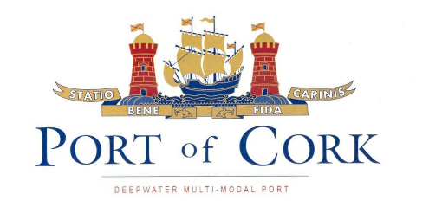
Procedure SEMS 06.08
First issue: 14.10.04
Revision: 1 date:07.12.05

PORT OF CORK

NOTICE TO MARINERS

NO. 19 of 2018

Gangways provided to vessels by the Port Company

Vessel Masters are reminded that when shore gangways are supplied to vessels by the Port Company, the gangway will always be certified, and the Master may request a copy of the test certificate.

Masters are always responsible to ensure that any gangway used by a vessel has safety nets rigged, lifebuoys in place, lighting is adequate, and a crew member is always stationed at the gangway.

This notice to mariners should be read in conjunction with SI 108 of 1988 ‘Means of access regulations’ and Marine Notice 38 of 2000.

CAPTAIN P. O’REGAN,

HARBOUR MASTER.

CUSTOM HOUSE STREET,
CORK.

13th December 2018.

