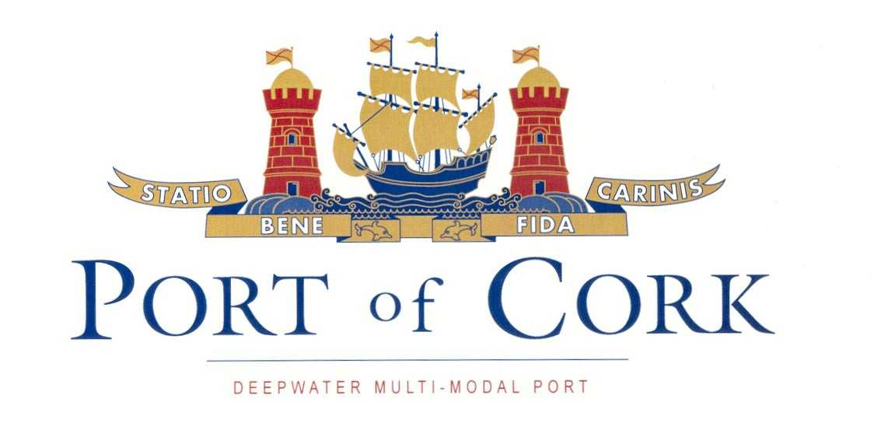
Procedure SEMS 06.08
First issue: 14.10.04
Revision: 1 date: 07.12.05

NOTICE TO MARINERS

Tern Raft

Admiralty Chart No 1777

NO. 5 of 2017

Mariners are advised that a concrete raft has been positioned in an approximate position of 51°50.14’N & 008°19.13’W (or 304° x 0.056’ from Ringaskiddy Pier on the Oyster Bank).

The raft, as requested by National Parks and Wildlife service, takes to the bottom (goes aground) during low tide and is UNLIT. The raft is part of a scheme to assist with the habitation of Terns, and as such must be given a wide berth. It is fitted with some equipment to encourage nesting of Terns, some of which emit a bird like sound.

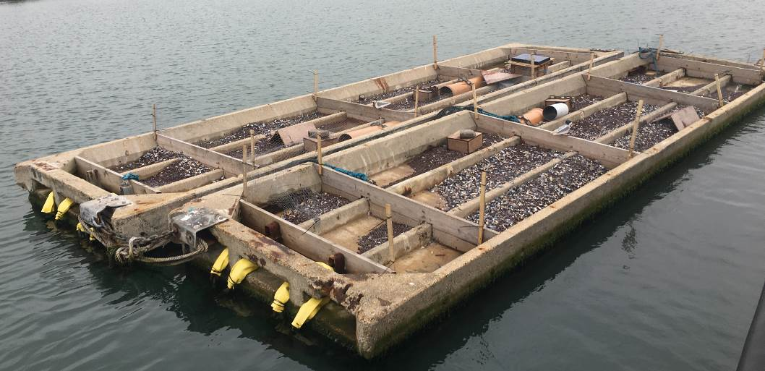
Mariners are advised to navigate with caution and at all times keep a proper lookout as per Rule 5 of the International regulations for preventing collisions at sea (COLREGs).

CAPTAIN P. O’REGAN,

HARBOUR MASTER

CUSTOM HOUSE STREET,
CORK.
27/06/2017

